

NEF 3002 APPLIED PROJECT II

SEMESTER 2, BLOCK 2, 2023

VIRTUAL FRIEND

CHAT BOT

FINAL REPORT



# AUTHOR: SUPERVISED BY:

Salon Thapa(s4662694)  Dr. Sardar Farhad

[Salon.thapa@live.vu.edu.au](mailto:Salon.thapa@live.vu.edu.au)

Robinson Karki (s4670336) SUBMISSION DATE:

[Robinson.karki@live.vu.edu](mailto:Robinson.karki@live.vu.edu) 15TH September 2023

**List of Figures**

Figure 3.1: Code for navigation panel…………………………………………….3

Figure 3.2: Code to handle file input………………………………………………4

Figure 3.3: Code to handle API Body Using GPT-3.5-Turbo……………..5

Figure 3.4: Function to handle add message…………………………………..5

Figure 3.5: Function to handle send messsage………………………………..6

Figure 3.6: Function to logout and readfile user uploaded data………6

Figure 9.1: Virtual Friend Home Page Interface………………………………9

Figure 9.2: Virtual Friend About Page Interface. 10

Figure 9.3: Virtual Friend Contact Page Interface. 10

Figure 9.4: Virtual Friend Signup page Interface. 11

Figure 9.5: Virtual Friend Login page interface. 11

Figure 9.6: Virtual Friend Chat Interface page. 12

# Executive Summary – Robinson Karki

This project started with the creation of a personalized virtual friendly chatbot, which evolved from a mobile phone concept to a user-friendly website. Key achievements include customizing use case diagrams, upgrading to ChatGPT 3.5 Turbo and implementing user-specific data training. The results exceeded initial expectations, providing an engaging and personalized chatbot experience. Lessons learned emphasize adaptability, thorough testing and robust data protection measures. The meaning of this project is to increase the well-being of users by creating meaningful connections through AI partnerships. It shows the technology's potential to enrich life and lay the foundation for future AI and NLP applications.

# Introduction – Robinson Karki

The journey that started with the creation of a personal virtual friend website was driven by innovation and a vision to develop an interesting and interactive website. Rooted in Natural Language Processing (NLP) and supported by the GPT-3.5 Turbo model, the project had a single goal: to create a virtual friend that could foster meaningful conversations with users by providing personalised responses based on their input.

* 1. **Project Background**

This report is the culmination of our efforts and a comprehensive assessment of the Personal Virtual Friend project. By delving into the intricacies of implementation, testing, challenges and ethical considerations, we aim to provide a holistic view of our journey.

Our search began with the creation of a virtual friend that would simulate the experience of a conversation with a real human partner. Thanks to the GPT-3 NLP model, our virtual friend is designed to understand user requests and respond to them accurately and consistently, making communication more interesting and realistic. The key to customising these interactions is fine-tuning the GPT-3 model, which allows the virtual friend to adapt to users' individual preferences and display different personality traits.

* 1. **Project Scope**

In the context of the evaluation report, the scope of the project focuses on the development of an advanced website designed to function as a personal virtual friend. Using the capabilities of GPT-3's Natural Language Processing (NLP) model, this initiative aims to enable interactive conversation between users and their virtual companions by generating contextual responses based on user input. The project includes essential elements such as user interface design, seamless integration with the GPT-3 API, and careful fine-tuning of the template for customization. Deployment on your chosen platform and ongoing maintenance and support are integrated to ensure a smooth user experience.

The project implementation plan includes providing API access to GPT-3, creating an intuitive user interface, developing a user interface to capture user input and display responses, integrating with the GPT-3 API for real-time communication, and fine-tuning the model. customized case, application deployment, and active monitoring of user feedback and usage patterns. Monitoring for continuous improvement. The project highlights user privacy and ethical considerations related to AI and NLP applications.

The project aims to provide users with an immersive and realistic virtual partner experience, led by a resolute team of three students who invest 30 hours a week. The duration of the project is 12 weeks.

* 1. **Project Objective**

The goal of the project "Customized virtual friend: GPT-3 NLP model-based web development" is to create a website to design a virtual friend using the GPT-3 natural language processing (NLP) model. This virtual companion is designed to engage users in personal, human conversations, helping, companionship and entertainment. Using GPT-3, it can provide consistent and contextual answers that adapt to different topics. The project aims to improve the well-being of users, foster connections, provide support and promote emotional and spiritual well-being.

The goals of this project are Specific, Measurable, Attainable, Relevant and Time Bound (SMART). These include simulating human interactions, personalizing reactions, improving user understanding, providing access to a large body of knowledge, providing emotional support, ensuring seamless integration between platforms, implementing a continuous learning mechanism, increasing user satisfaction through intuitive user interfaces, developing robust user interfaces back-end systems that prioritize user privacy, performance optimization, user feedback, and a reliable and scalable application or website for widespread use.

# Project Implementation Process – Robinson Karki

* 1. **Detailed Description of Implementation Process**

Our project to create an AI chat room for a virtual friend progressed along a 12-week timeline. During this time, we successfully navigated the complexities of making our vision a reality. Our implementation process involved several key steps:

* **Conceptualization:**

We started the project by brainstorming the idea of ​​a virtual friendly chat. This involved defining the main goals and capabilities of the chat, such as personalized responses and information service capabilities.

* **Technology Selection:**

Our journey was based on the selection of key tools and technologies. We used Visual Studio, Xampp and my SQL to manage the database, and the API key GPT-3.5 for natural language processing. Although we originally intended to use Python for backend development, compatibility issues led us to use Java and PHP. The user interface was designed using HTML and CSS.

* **Challenges Faced:**

During the implementation process, we encountered several challenges. We had problems getting information from the GPT 3.5 turbo API, and we had problems logging in due to SQL errors. We also faced not getting response as per user desire.

* **Development:**

We have carefully developed the chat, ensuring that it can accept user input, provide meaningful responses, and seamlessly retrieve data from the GPT 3.5 turbo API when needed. Different user can train their own data and get meaningful responses.

Here we have code for chat interface:

**Code for Navigation Panel & Chat Box of chat interface:**

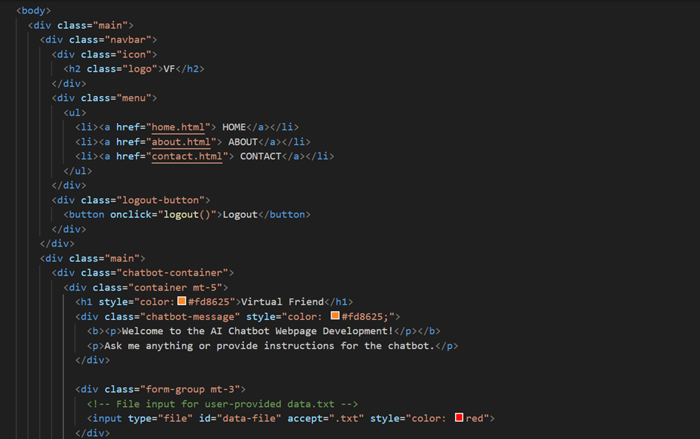

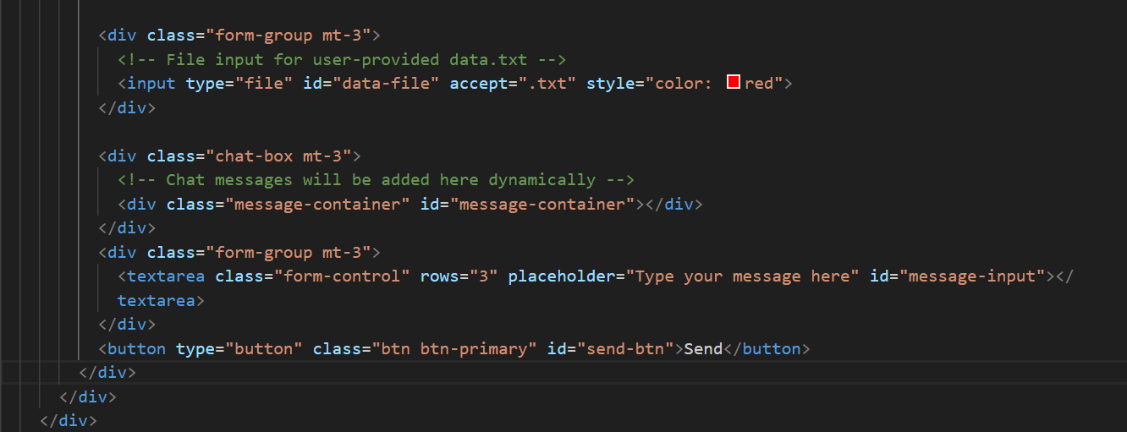

Figure 3.1: Code for Navigation Panel

**Backend Code to run the chat interface and get responses:**

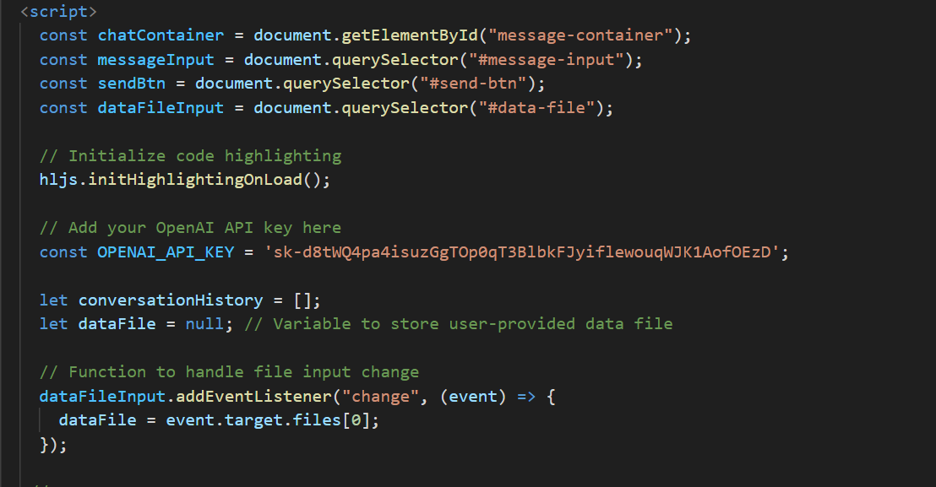

Figure 3.2: Code to handle file input.

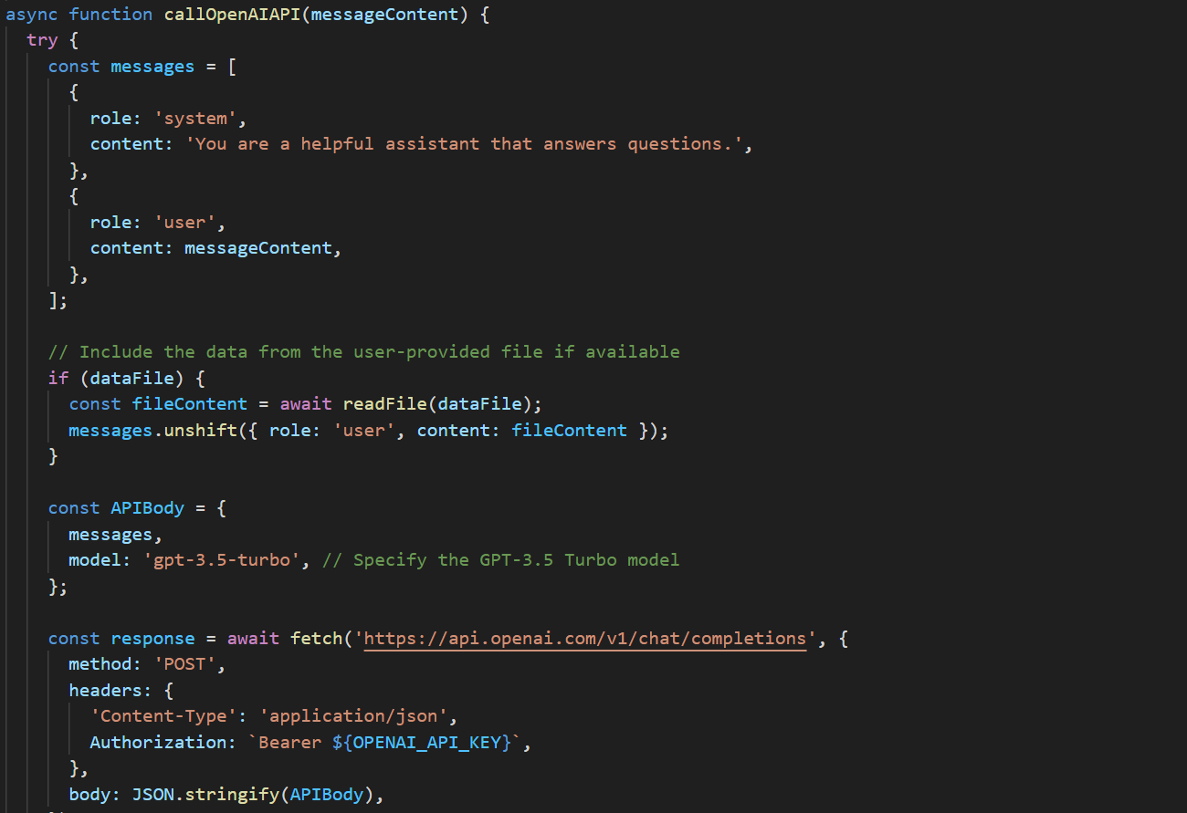

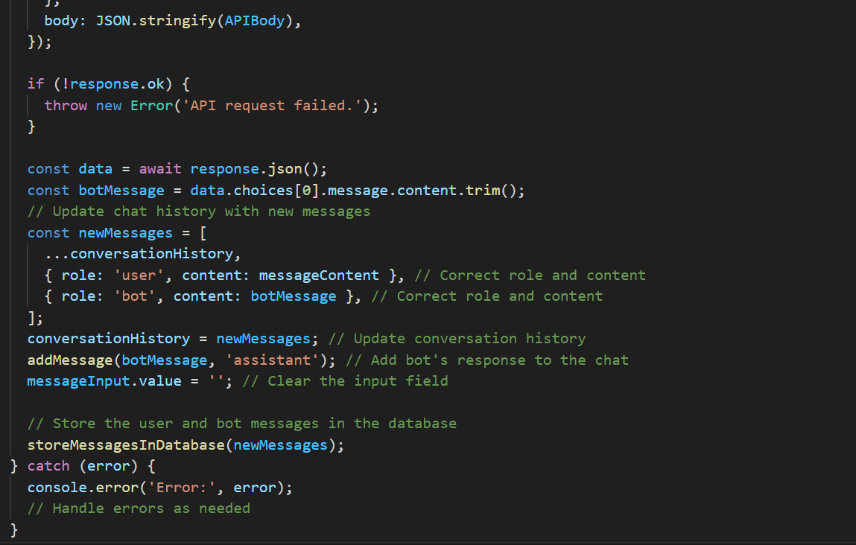

Figure 3.3: Code to handle API Body Using GPT-3.5-Turbo

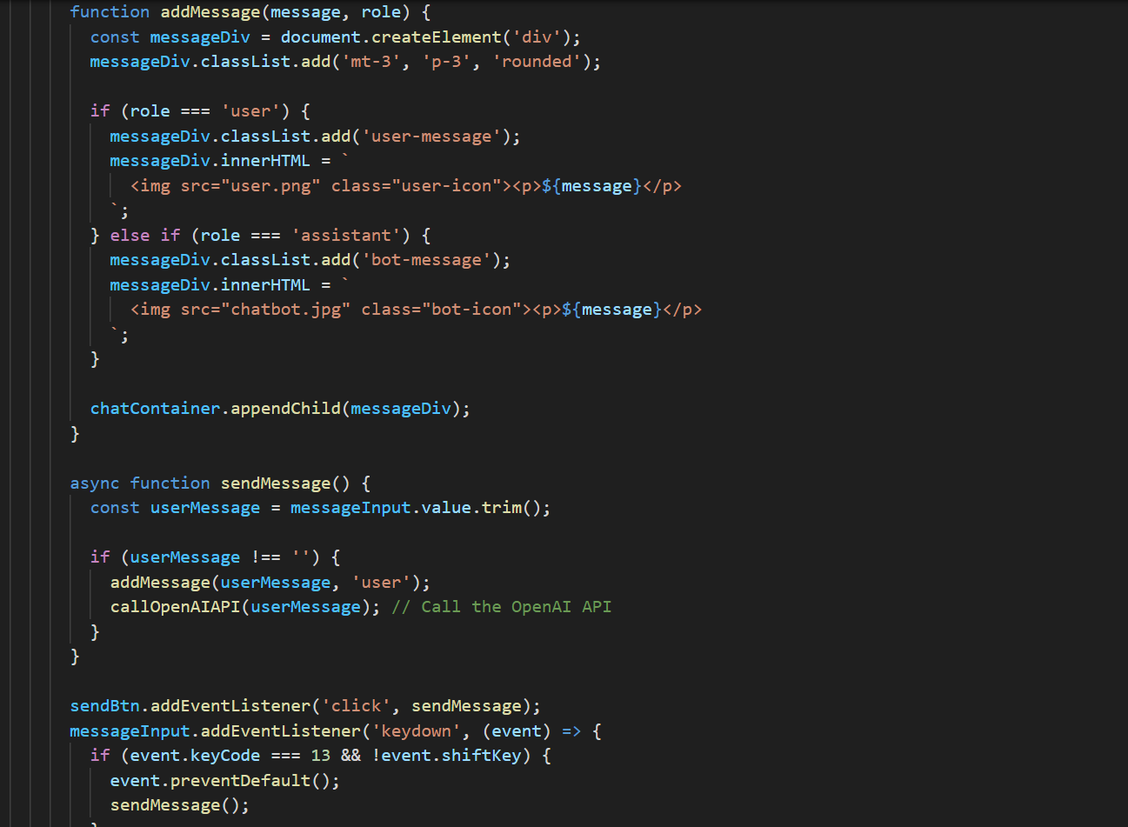

Figure 3.4: Function to handle add message.

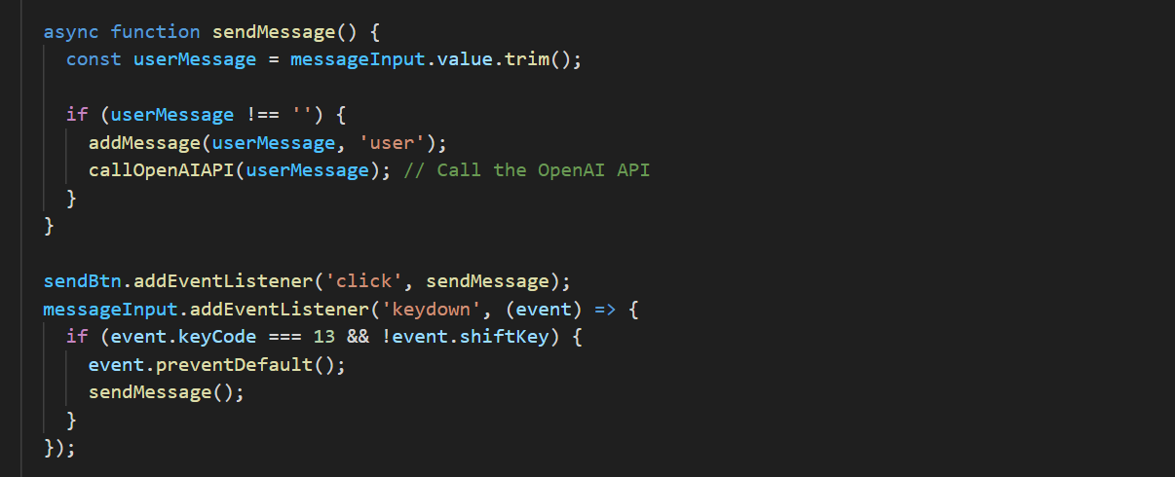

Figure 3.5: Function to handle send message.

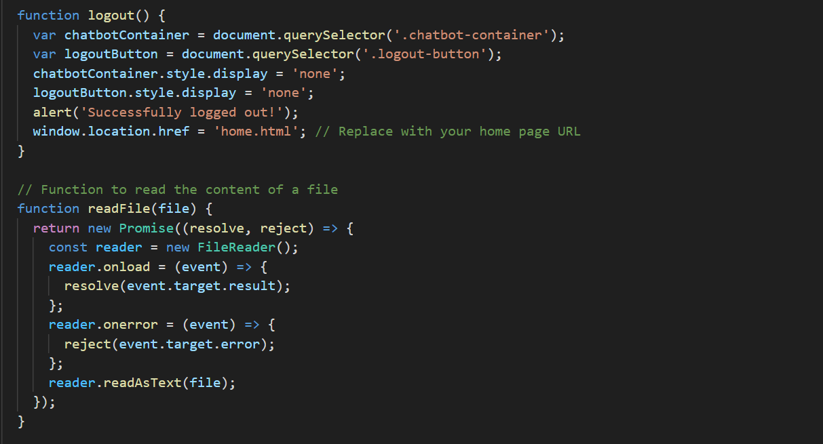

Figure 3.6: Function to handle logout and read file of user uploaded data.

* 1. **Methodologies and Tools Employed**
     1. **Methodologies:**

**Hybrid Agile and Waterfall approach**: Our project followed a hybrid approach that combined both Agile and Waterfall methodologies. This approach allowed for flexibility and adaptability while ensuring continuous development.

* **Agile:**

Agile methodologies emphasize iterative development, collaboration, and customer feedback. Agile principles helped your project adapt to changes such as moving from Python to Java to PHP when compatibility issues arose.

* **Waterfall:**

Waterfall methodologies involve a structured sequential approach to development where each stage must be completed before moving on to the next. This structure ensured that critical project milestones were achieved in a logical sequence.

* + 1. **Tools:**

We used different software and tools for development of your project with or mentioned below.

* **Visual Studio:**

Visual Studio is a popular integrated development environment (IDE) that supports multiple programming languages. It played a key role in the coding and debugging of our project.

* **Xampp and my SQL:**

Xampp is an open-source software that provides a local server environment for web development. MySQL is a widely used relational database management system. Together, they made our project database easier to manage, store and search. It also helps our website to run through the local host environment.

* **GPT-3.5 API Key:**

GPT-3.5 Turbo is OpenAI's powerful Natural Language Processing (NLP) model. With an API key, our project can use this advanced NLP functionality to generate meaningful responses in our virtual friend chat.

* **Java and PHP**:

These programming languages ​​were used for the backend development of the chat. When Python compatibility issues arose, the decision to switch to Java and PHP were made to adapt and solve problems.

* **HTML and CSS:**

HTML (Hypertext Markup Language) and CSS (Cascading Style Sheets) were used to develop the user interface. HTML created the content of your web pages, while CSS was used to design and style the user interface, ensuring an attractive and user-friendly design.

Overall, the hybrid approach of Agile and Waterfall provided a flexible but structured framework for project development. Versatile tools such as Visual Studio, Xampp, MySQL, GPT-3.5 API key, Java, PHP, HTML and CSS together allowed us to handle various aspects of the project, from coding and database management to NLP features and front-end design. This combination of methods and tools helped to successfully implement our virtual friend chatbot.

* 1. **Timeline, Milestones, and Schedule Analysis**

Our project schedule was set at 12 weeks, which we diligently followed. We successfully completed our project in the agreed time.

Milestones achieved during our implementation process included:

* Conceptualization and launch of a project.
* Choice of technology and installation of tools
* Overcoming initial challenges with Python and transitioning to Java and PHP
* Chatbot UI and backend development
* Addressing API integration challenges
* Successful completion of chat with data search capabilities
* The project schedule was strictly observed, and it was ensured that every milestone was achieved within the specified time frame.
  1. **Critical Analysis and Reflection on Implementation Process**

Our journey was not without trials. Getting data from the GPT 3.5 turbo API and logging issues from my SQL errors created major obstacles. However, the flexibility and adaptability of our team allowed us to overcome these obstacles.

While our journey was not without challenges, such as difficulties with the GPT 3.5 turbo API and SQL login errors, our team's flexibility enabled us to overcome these obstacles. Reflecting on our project, we recognize both its strengths and limitations:

* **Adaptability:**

The seamless transition from Python to Java and PHP highlighted our ability to adapt to unforeseen issues.

* **Testing and Troubleshooting:**

We acknowledge the importance of thorough testing and troubleshooting in future projects to minimize challenges.

* **Ethical Considerations:**

Privacy and data protection were paramount, and we successfully integrated these principles into our application process. We had understood the user data privacy.

In conclusion, our virtual friend chatbot project marks a journey filled with successful milestones and valuable lessons. By combining effective methodologies, careful tool selection, adherence to our schedule, and a resilient approach to challenges, we realized our vision. These critical analyses and reflections lay a solid foundation for future endeavours in AI and NLP applications.

# Testing and Quality Assurance - Robinson Karki

* 1. **Testing Methodologies:**
* **Unit Testing:**

This method focused on evaluating the individual components of the system, making sure that each part is working properly. This involved evaluating the functionality of various modules including user registration, login, and chat.

* **Integration Testing:**

The goal of the Integration Testing phase was to ensure the interaction and data flow between various system components such as the UI, backend, and GPT-3.5 Turbo API integration. This ensured smooth communication and exchange of information.

* **User Acceptance Testing (UAT):**

UAT was used to evaluate the product from the perspective of the end user. In it, real users interacted with the chat to rate its performance, ease, and ability to meet their needs.

* **Functional Testing:**

This method was used to verify that the system functions meet the design requirements. This confirmed that the chat provided meaningful responses based on user input and adapted to different scenarios.

* 1. **Identification of Testing Challenges and Resolutions:**
* **GPT-3.5 Turbo API Access:**

There were initially challenges getting accurate responses from the GPT-3.5 Turbo API. The solution involved checking the API integration and tuning the model to get a better response.

* **SQL errors:**

SQL errors caused problems during testing. The solution involved debugging to remove errors and fine-tune database interactions.

* **User Concerns:**

User concerns about chatbot responses have been addressed through iterative testing and improvement. Feedback loops enabled continuous improvement based on user expectations.

* **Python Switch to Java and PHP:**

Python's compatibility problems prompted the switch to Java and PHP. This change was managed by adapting existing code and ensuring a smooth transition.

Overall, the testing methods used, including unit testing, integration testing, UAT and functional testing, collectively contributed to product quality assurance. Challenges were identified and addressed, resulting in a more powerful and user-friendly virtual chat room. The user feedback loop was key to improving product performance and ensuring quality.

# Schedule Management - Robinson Karki

5.1. Reviewing project schedule and deviations

Our project followed a carefully planned 12-week schedule, ensuring that every milestone was completed on time. This disciplined approach allowed us to maintain project momentum and stay on track.

**5.2. A discussion of how to manage schedule changes.**

While the project was mostly on schedule, there was a major deviation when we switched from initially choosing Python for backend development to using Java and PHP due to compatibility issues. This change required quick thinking and adaptability.

We managed this schedule change effectively by quickly assessing the situation, researching alternative programming languages, ​​and making an informed decision. Our ability to turn around shows the flexibility and commitment of our team to achieve project goals.

This experience emphasized the importance of extensive testing and troubleshooting to minimize future schedule disruptions. Despite the deviation, we successfully completed the project within the planned 12-week schedule, which highlighted the flexibility and commitment of our team to complete the project.

# Challenges and Problems - Salon Thapa

There are various challenges and problems we had faced during implementation of our project.

* **Implementation of GPT-3.5 Turbo:**

One of the main challenges was migrating from GPT-3 to GPT-3.5 Turbo due to compatibility issues. Although GPT-3.5 Turbo offered better performance, the migration required changes in coding and API integration. Solutions included revising the code base and ensuring seamless API integration (Brown et al., 2020).

* **Data training:**

Initially, the project lacked a data training mechanism, which led to limited user-specific responses. The challenge was met with the introduction of data training, which allows users to customize their chatbot data (Radford et al., 2019). SQL Errors: Common SQL errors prevented user registration and data management. Solutions included debugging SQL queries, optimizing database interactions, and improving error handling (Grainger, 2016).

* **Privacy and Ethical Considerations:**

Ensuring user privacy and the ethical use of AI was paramount. Solutions included implementing privacy-focused design principles, encryption, and adherence to ethical AI guidelines (Floridi et al., 2018).

* **User Feedback and Iteration:**

Gathering user feedback for iterative improvements has been a challenge. Solutions included user testing, feedback collection mechanisms, and agile development methodologies (Sommerville, 2011).

* **Deployment Complexity:**

Deploying a website on a domain created technical complexities. Solutions focused on domain hosting and DNS resolution issues (Svantesson and Clarke, 2010).

Addressing these challenges with adaptive strategies ensured the successful development and implementation of personalized virtual friend chat.

* **Transition from Python to Java and PHP:**

Compatibility issues with Python prompted the switch to Java and PHP for backend development. This change required adapting the code base and redefining the development method to ensure smooth continuity of the project.

Addressing these challenges with adaptive strategies ensured the successful development and implementation of personalized virtual friend chatbot.

# Strengths and Limitations of the Product - Salon Thapa

**7.1. Strengths:**

* **Personalization:**

Personalized virtual friend chat offers a highly personalized interaction with users. Data training allows users to tailor chatbot responses, improving the user experience.

* **Natural language processing:**

Using the GPT-3.5 Turbo model, the chat has advanced natural language understanding and generation capabilities. It can participate in human conversations by providing relevant and context-aware responses.

* **User-friendly interface:**

The user interface is designed to be intuitive and user-friendly. Users can interact with the chat seamlessly, making it accessible to a wide audience.

* **Ethical Considerations**:

The project demonstrates a commitment to ethical AI development by prioritizing user privacy and data protection and following new AI ethics guidelines.

* **Adaptability:**

The transition from Python to Java and PHP demonstrated the adaptability of the project by responding to technical challenges and ensuring project continuity.

**7.2. Limitations:**

* **Chat History:**

One major limitation is the inability to save messages from users and chatbots to the chat history. This feature, which allows users to view past conversations, is currently lacking and is an area that needs further development and improvement.

* **Variation from original website design:**

There is a difference between the original website design discussed in the design and analysis and the actual result. This can lead to differences in user experience expectations.

* **GPT-3 vs. GPT-3.5 Turbo:**

Originally considering GPT-3 but implementing GPT-3.5 Turbo may cause differences in performance and results, affecting user expectations.

* **Data Training:**

The initial project did not include ChatGPT training with user data, while the final product allows data training. This major change may affect user interaction and responses.

* **Chatbot Response Challenges:**

Challenges with GPT 3.5 Turbo API usage and SQL errors initially caused difficulty in getting accurate responses, which affected user satisfaction.

Overall, the product has excellent customization, advanced NLP technology integration and a friendly interface. However, it faces challenges in managing chat history, changing the original scope, and dealing with user issues, and suggests areas for further development and improvement.

# Project Evaluation - Salon Thapa

**8.1. Project results and achievements**

Our project to develop a personalized virtual chat room has produced remarkable results and achievements. Let us familiarize ourselves with the results and achievements of the project:

* **Refining the use case diagram:**

In the planning and analysis phase, we initially sketched out the use case diagram for the virtual friend mobile application. This diagram was a major step in understanding user interaction. But as we progressed, we refined the diagram to better meet the changing needs of the project.

* **User Interface Development:**

During the design and analysis phase, we envision a specific web page layout, including separate pages to interact with the chat. However, during the implementation phase, we adapted and developed the user interface to better suit user preferences and project requirements. As a result, the appearance of the site has undergone significant changes.

* **Website Development:**

Although the initial design and analysis phase focused on the mobile application, the project later led to the development of the website. These sites provide a platform for users to interact with a chat room and get answers right on the same page.

8.2**. Project Scope Vs Deliverable**

Comparing the original project scope with the actual results, we can highlight the following key differences.

8.2.1**. Initial Project Scope:**

* Design and analyse a virtual friend for a mobile application.
* Create a use case diagram to understand user interaction.
* Imagine separate pages for chatbot responses.
* Covered by ChatGPT 3.

**8.2.2. Actual Outcomes:**

* Websites designed for user interaction.
* Refined use case diagram to adapt to project requirements.
* A one-page user interface for communication between chatbots was introduced.
* Used ChatGPT 3.5 Turbo improves natural language processing capabilities.
* Created feature to train ChatGPT with user specific data and generate responses based on personal datasets.

In summary, the scope of the project has evolved over time, leading to a transition from mobile apps to user engagement websites. In addition, the use case diagram was refined, and the user interface design was adapted to improve the user experience. The project has also moved from ChatGPT 3 to the more advanced ChatGPT 3.5 Turbo, which offers advanced natural language processing capabilities. A particularly important addition was the ability to train ChatGPT with user data, resulting in personalized and context-aware responses. This feature was not originally designed, but valuable for users.

# User Interface Diagram - Salon Thapa

After implementing successful project, we had created virtual friend chatbot and designed the user-friendly user interface diagram.

* 1. **Home Page Diagram**

In our website we had design our homepage and make it user friendly. User can login in home page to access chat interface. User can also signup their account by clicking signup button present in home page. User can navigate in about page to get information about the websites and user can also navigate into contact page for contact the chat bot support and provide feed back of the websites.

: 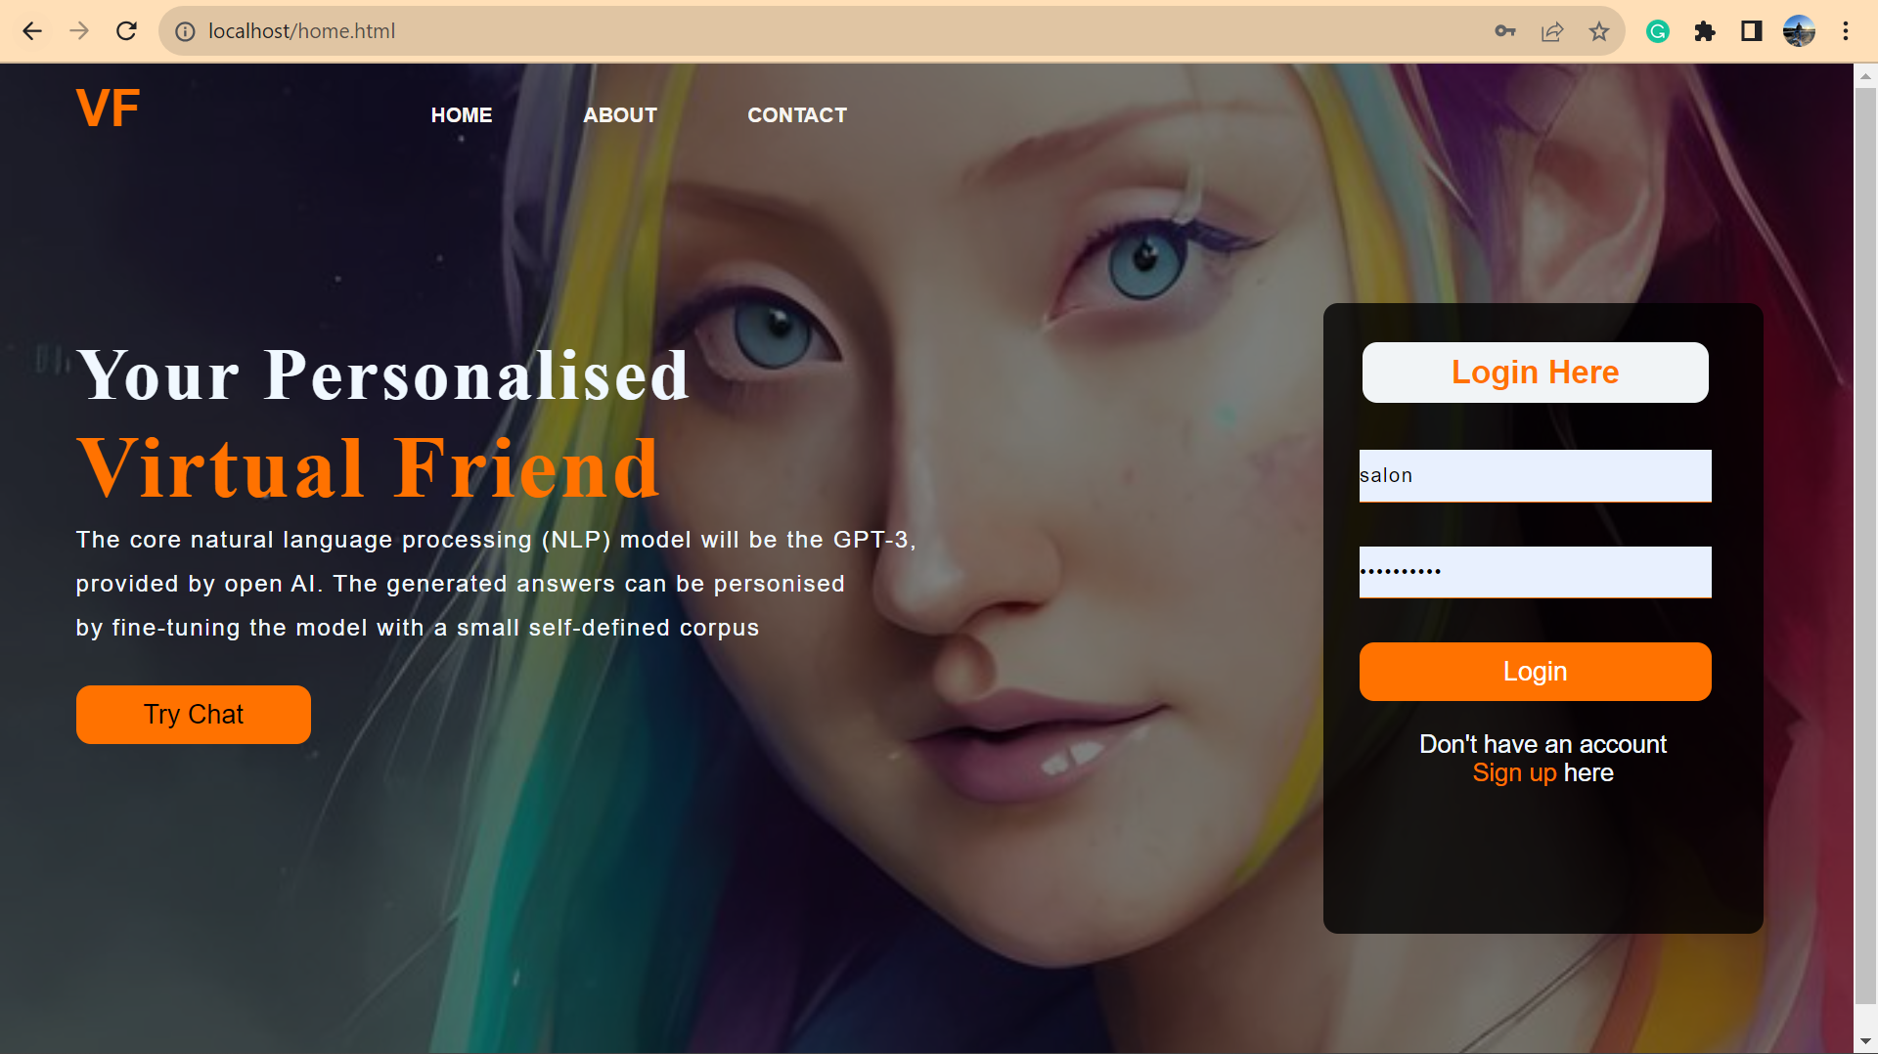

Figure 9.: Virtual Friend Home Page Interface.

* 1. **About Page Diagram**

In this about page, it contains user detailed description of Virtual Friend websites, that we had created after successfully after 12 weeks timeline. 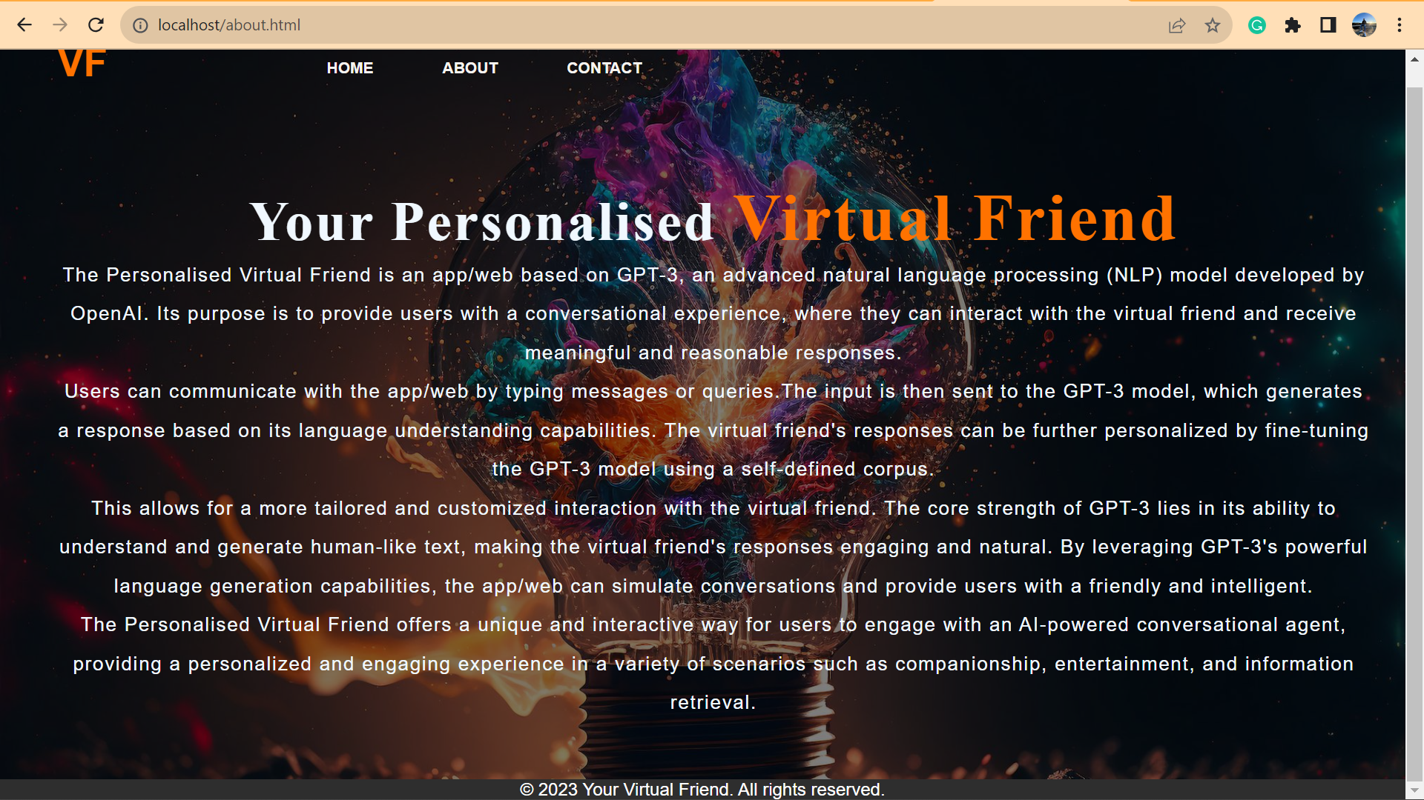

Figure 9.: Virtual Friend About Page Interface.

* 1. **Contact Page Diagram**

In this contact page of our virtual friend chat, User can fill up the contact information and leave comments and feed back to virtual friend support centre about the chat bot. 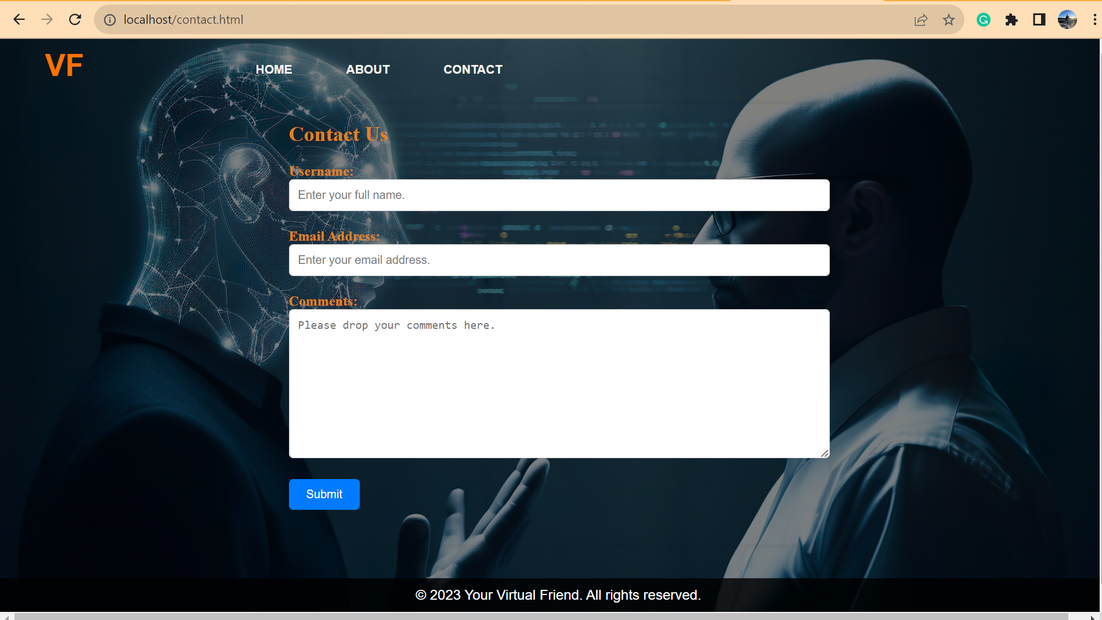

Figure 9.: Virtual Friend Contact Page Interface.

* 1. **Signup Page Diagram**

In this signup page of virtual friend chat website, User can register their account by filling up register form. After filling up register form email is sent to user account about activation of their account and user data are stored in my SQL database with user privacy. After successful registration it will direct user to login page for further interaction with chat bot. 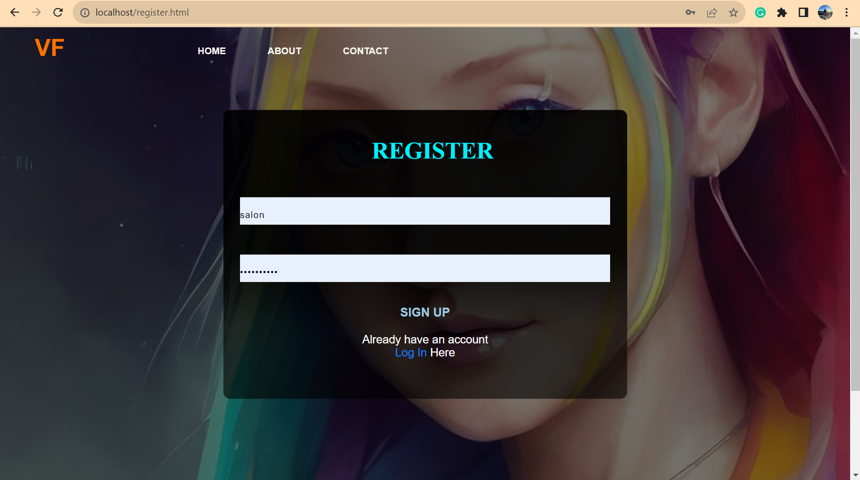

Figure 9.: Virtual Friend Signup page Interface.

* 1. **Login Page Diagram**

In this login page user login to interact with chatbot. After login it will direct user to chat interface if user account has exits. 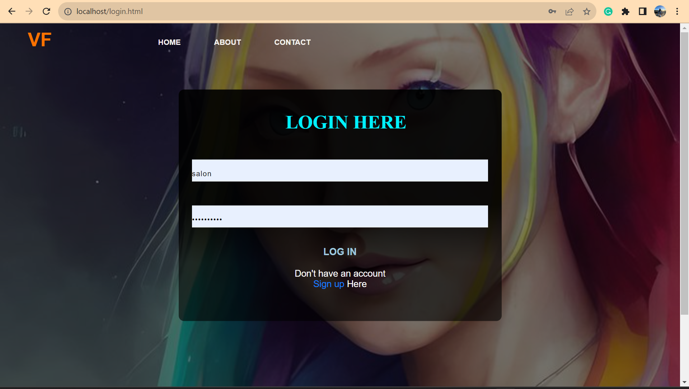

Figure 9.: Virtual Friend Login page interface.

* 1. **Chat Interface Diagram**

After successful login, it will direct user to chat interface where user can interact with chatbot and provide own data to get meaningful responses. If it is out of data, then it will generate response based on ChatGPT 3.5 turbo. User can also logout the chat interface and after logout it will direct user to home page of websites. 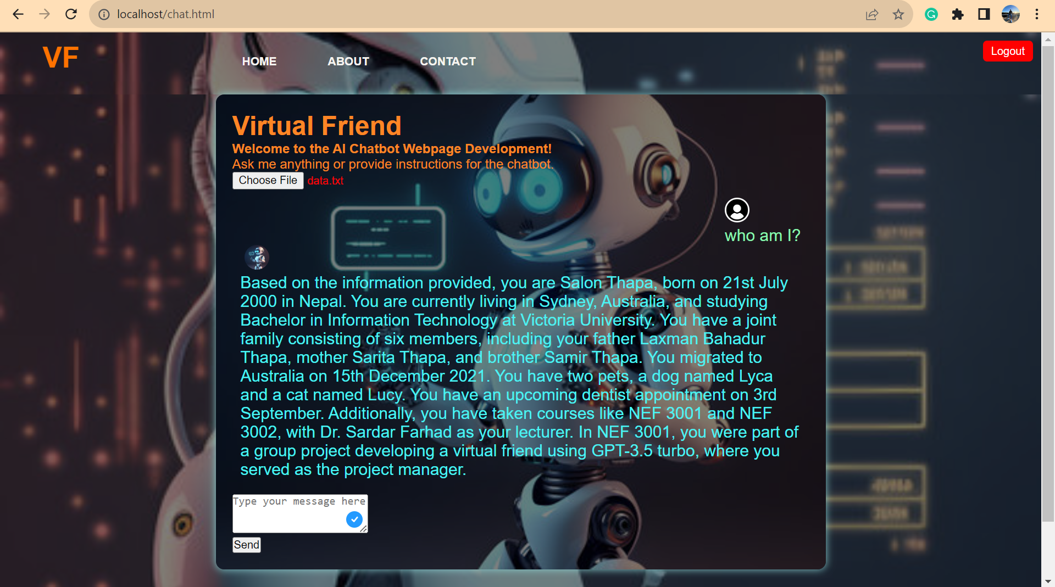

Figure 9.: Virtual Friend Chat Interface page.

# Recommendations for Future Improvement - Salon Thapa

Considering the successful development of the virtual friendly website, there are several important recommendations and ways to make the project more effective for future work:

* **Improve privacy:**

Strengthen user privacy by implementing data encryption, stricter access rights and compliance with data protection regulations such as GDPR.

* **Data Enrichment**:

Collect more user data (with consent) to improve the chat's ability to provide personalized responses and tailor interactions.

* **User Reviews:**

Continuously process user feedback to improve user satisfaction and tailor chatbot r responses based on real user experiences.

* **Password updates:**

To improve the security of user accounts, enable the secure password update feature.

* **Improved user-friendliness:**

Improve the user interface for a smooth and intuitive user experience during usability testing. Domain Deployment: Move from a local host to a dedicated domain to improve wider availability.

* **Interactive chat interface:**

Invest in a more interactive chat interface and explore multimedia integration.

* **Advances in Machine Learning and NLP:**

Keep up with machine learning and NLP advancements to improve your chat capabilities.

* **Information security audits:**

Regularly check and reduce potential vulnerabilities.

* **Scalability:**

Plan for future scalability with a growing user base.

* **User Training:**

Provide training and educational resources to users.

* **Research Opportunities:**

Explore emerging trends and technologies in AI and chatbots for integration.

These recommendations and future areas of work aim to improve the functionality, user experience and security of the virtual friendly website at the same time as evolving AI technologies and user expectations.

# Computer Ethics and Project - Salon Thapa

**11.1. Discussion of ethical aspects related to the project.**

In the field of artificial intelligence and NLP, ethics is a critical compass. We took several ethical aspects seriously during our journey:

* **User privacy:**

Your privacy is important. We have made sure that your conversations with our virtual friend remain confidential. Your information is protected, encrypted, and will not be shared without your consent.

* **Transparency:**

Trust is critical. We told you directly that our virtual friend is an AI, not a human. Honesty and openness were essential to build trust and prevent any deception.

* **Bias and fairness:**

Our chat room tries to provide unbiased answers. We have actively worked to ensure that this is not skewed in the answers so that you receive fair and accurate information.

* **Use of data:**

We have treated your data ethically. Your information will only be used to improve your interactions with our chat and improve its responses. We do not share your information with third parties for commercial purposes.

**11.2. Consider the ethical issues that have arisen.**

We have met and thoroughly considered ethical issues:

* **Balance of personalization and privacy:**

Finding the right balance between personalization and privacy has been a challenge. We wanted to improve your user experience while protecting your privacy.

* **Addressing controversial topics:**

Responsible discussion of sensitive or controversial topics was a priority. We strive to provide accurate and unbiased information while navigating complex topics.

* **AI's Role in Emotional Support:**

Our chat can provide companionship, but it cannot replace human emotional support. We explained that professional help should always be sought if necessary.

**11.3. Analysis of ethical decisions made during the project.**

Our ethical decisions include transparency, data protection, reducing bias and emphasizing the role of the chat as a support tool. We have tried to align our project with ethical standards and ensure that it contributes positively to your well-being. In short, our project was driven by ethics. We prioritize your privacy, transparency, fairness, and responsible use of data to create an AI chat that respects your values ​​while providing valuable interactions. User data will protect as per privacy policy of Open AI. (<https://openai.com/policies/privacy-policy>)

# Conclusion - Salon Thapa

In summary, it can be stated that the journey from the beginning to the end of the project yielded meaningful results and lessons. What started as a vision for a mobile app has evolved into interactive websites that provide personalized experiences. Findings include adapting use case diagrams, migrating to ChatGPT 3.5 Turbo and adding user-specific data training. Valuable lessons emphasize adaptability, rigorous testing, and privacy. The importance of this project is to improve the well-being of users through a personalized AI partnership, which lays the foundation for future AI and NLP applications. It highlights the potential of technology to create meaningful connections and enrich lives.

# References - Robinson Karki & Salon Thapa

1. Brown, T. B., et al. (2020). Language Models are Few-Shot Learners. arXiv preprint arXiv:2005.14165.
2. Radford, A., et al. (2019). Language Models are Unsupervised Multitask Learners. OpenAI Blog.
3. Grainger, R. (2016). SQL Injection Attacks and Defense. Syngress.
4. Floridi, L., et al. (2018). AI4People—An Ethical Framework for a Good AI Society: Opportunities, Risks, Principles, and Recommendations. Minds and Machines, 28(4), 689-707.
5. Sommerville, I. (2011). Software Engineering. Pearson Education.
6. Svantesson, D., & Clarke, R. (2010). Privacy and consumer risks in domain name services. Journal of Law, Information & Science, 20(2), 181-206.
7. OpenAI (2023). ChatGPT. [online] chat.openai.com. Available at: https://chat.openai.com/.
8. Jay. (2023, March 26). What is a Virtual Friend and How Does It Work? Gig Hustlers. https://gighustlers.com/what-is-a-virtual-friend-how-does-it-work/
9. DeepLearning.AI. (2023, January 11). Natural Language Processing (NLP) - A Complete Guide. Www.deeplearning.ai. https://www.deeplearning.ai/resources/natural-language-processing/
10. Jay. (2023, March 26). What is a Virtual Friend and How Does It Work? Gig Hustlers. https://gighustlers.com/what-is-a-virtual-friend-how-does-it-work/

Thank you!